

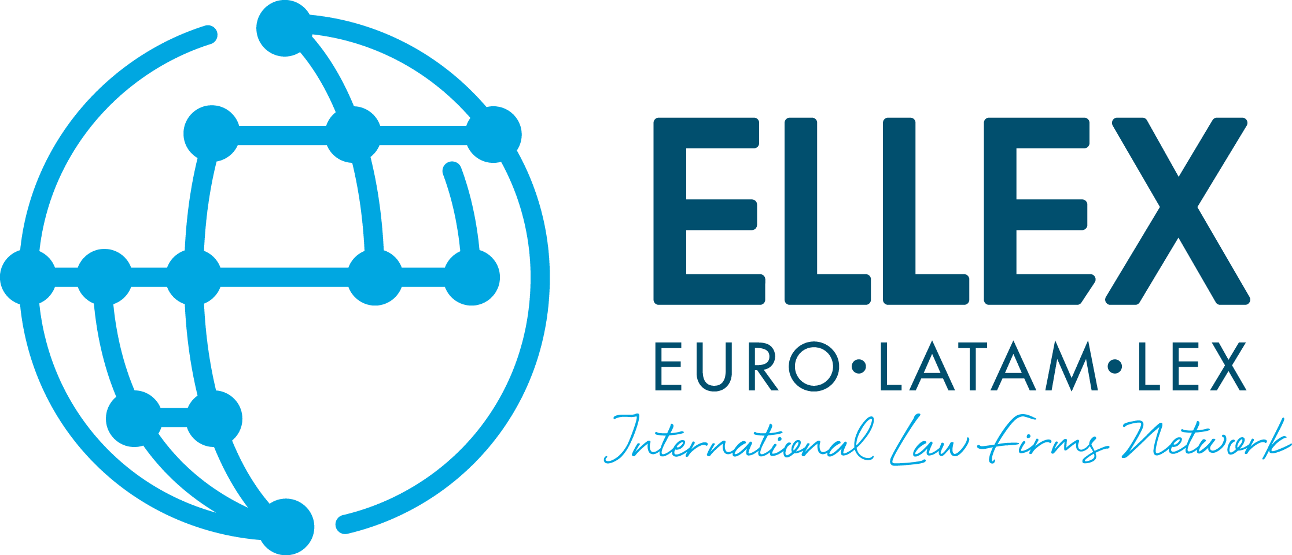

III International congress Euro-Latam Lex
“Digital Security, Rights and Liberties”

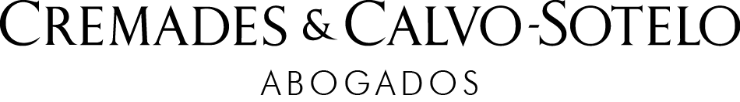

Madrid, 26-27 October 2017

Thursday, October 26

09:00h Reception and Registration (6th floor)

09:30h Welcome to the conference (7 th floor)

“Membership and cooperation between Euro-Latam Lex attorneys: Evaluación and Expectations of Ellex; Special Cases”.
Javier Cremades, Co-Chairman of Euro Latam Lex (ELLEX) and President of Cremades & Calvo Sotelo (Madrid, Spain).

“Present Relations European Union / Latin America: Opportunities and challenges”.
Benita Ferrero-Waldner, Co-Chair of Euro Latam Lex (ELLEX) and Partner at Cremades & Calvo Sotelo, former European Commissioner for External Relations and former Minister of Foreign Affairs (Madrid, Spain).

Brief Welcome to the Conference:

Vicente Conde, Partner of Cremades & Calvo-Sotelo, Judge Emeritus of the Constitutional Court and Judge Emeritus of the Supreme Court (Madrid, Spain).

Juan Ortiz Úrculo, Partner of Cremades & Calvo-Sotelo, Former Attorney General, Chief Prosecutor of the Constitutional Court (Madrid, Spain).

Juan Saavedra Ruiz, Partner of Cremades & Calvo-Sotelo Judge Emeritus of the Supreme Court and President of the Criminal Chamber of the Supreme Court (Madrid, Spain).

Jose María Alvarez del Manzano, Partner of Cremades & Calvo-Sotelo and former Mayor of Madrid, Spain.

10:30h I Working session

“The New Collaborative Economy, Challenges & Opportunities”.
Diego Solana, Attorney at Cremades & Calvo-Sotelo (Madrid, Spain).
Anna Trallero, Head of Legal Cabify (Madrid, Spain).
José Luis Zimmermann, Director General Adigital (Madrid, Spain).
José Francisco Estévez, Attorney and Vice-President at Cremades & Calvo-Sotelo (Madrid, Spain).

11:30h Networking and Coffee Break (5th floor)

12:30h II Working Session

“Cyber security and legal challenges in the 4º industrial revolution”.
Francisco Ginel, Vice President of Channels and Partnership of Randed (Madrid, Spain).
João Caiado Guerreiro, Attorney at Caiado Guerreiro (Lisbon, Portugal).
James Black, Attorney at Silverman Acampora (New York, United States).
Carsten Moser, former President of the Spanish-German Chamber of Commerce, Vice-President Euro-America Foundation (Madrid, Spain).

13.30h III Working Session

“A review of international cases”

“Banco Popular Case”
Ernesto Trigueros, Attorney and Partner at Cremades & Calvo-Sotelo (Madrid, Spain).

“How the new labor law can increase legal security in Brazil for foreign investors”
Renato Melquíades, Attorney at Araújo, Martorelli Advogados (Recife, Brazil).

“Implementation of the new national anti-corruption system in Mexico and its practical consequences for companies.”
Yves Hayaux-du-Tilly L., Attorney at Nader, Hayaux & Goebel (Mexico and UK).

"The Corporate Criminal Liabilty in Italy: the application of Law 231/01 to foreign companies in case of cross border activities”

Matteo Pozzi, Attorney at Studio Isolabella, (Milano, Italy).

Luigi Isolabella della Croce, Attorney at Studio Isolabella (Milano, Italy).

14:30h Cocktail & Buffet lunch
Hosted by Javier Cremades, at his Residence (Alcalá 101, 6ͭ ͪfloor)

15:00h IV Working Session
Hosted by Javier Cremades, at his Residence (Alcalá 101, 6ͭ ͪfloor)

“Legal insecurity in Venezuela and investment protection in Ibero-American countries”.
Juan Domingo Alfonzo, Attorney at Torres Plaz Araujo (Caracas, Venezuela).
Leopoldo López Gil, father of the Venezuela opposition leader Leopoldo López Mendoza (Caracas, Venezuela).

“Corporate governance in the Brazilian institutional development”
Francisco Petros, Attorney at FF Advogados (Sao Paulo, Brazil).

"La inversión Extranjera en la República del Ecuador"
José Rafael Bustamante, Chairman at Bustamante & Bustamante Law Firm (Quito, Ecuador).

17:00 Transfer to the Spanish State Council
(Departure from Velázquez street with Alcalá).

17:30h Institutional visit to the Spanish State Council

19:00h Transfer back to the Wellington Hotel

21:00h Gala Dinner
At Wellington Hotel (Velázquez street, 8, Madrid)
Welcoming Remarks.

Friday, October 27

09:45h Welcome - Offices of Cremades & Calvo Sotelo

“Welcome and Introductory Remarks”

Benita Ferrero-Waldner, Partner of Cremades & Calvo-Sotelo, President of the Advisory Council and former EU Commissioner for External Relations and Neighbourhood Policy (Madrid, Spain).

10:00h I Working Session

“European Union - current challenges”

Javier Solana, former High Representative for the Common Foreign and Security Policy/Secretary General of the Council of the European Union. President of the Center for Global Economy and Geopolitics ESADE (Madrid, Spain).

Debate

11:00h II Working Session

“Challenges and opportunities in Ibero-America”

Enrique Iglesias, former Secretary General of SEGIB, Ibero-American General Secretary (Madrid, Spain/Uruguay).
João Vale de Almeida, Ambassador of the European Union to the United Nations (Lisbon, Portugal).
Pablo Zalba Bidegain, President of (ICO), Instituto de Crédito Oficial (Pamplona, Spain).

13:00h Closing Ceremony

13.15h Transfer to “Roca del Buho”
From Cremades & Calvo Sotelo (Jorge Juan Street, 30)

14.30h Lunch at the “Roca del Buho”
(Residence of President Javier Cremades)

17.00h Transfer to San Lorenzo de El Escorial

17.30h Visit to the Royal Site of San Lorenzo de El Escorial UNESCO World
Heritage Site

18.45h Transfer back to Madrid

